**STUDY OF ROAD CONNECTIVITY IN OGBOMOSO NORTH**

**BY**

**AKINDEERE, ZAINAB ABIKE (182615)**

**BEING A PROJECT SUBMITTED TO**

**THE DEPARTMENT OF TRANSPORT MANAGEMENT,**

**FACULTY OF MANAGEMENT SCIENCES,**

**LADOKE AKINTOLA UNIVERSITY OF TECHNOLOGY**

**OGBOMOSO, OYO STATE, NIGERIA.**

**IN PARTIAL FULFILMENT OF THE REQUIREMENTS FOR THE AWARD OF**

**BACHELOR OF TECHNOLOGY (B. TECH) IN TRANSPORT MANAGEMENT.**

**DECEMBER 2023.**

# CERTIFICATION

This is to certify that all the activities in this project report was carried out by **Akindeere, Zainab Abike (Matric No: 182615)** of the department of Transport Management, Faculty of Management Sciences, Ladoke Akintola University of Technology, Ogbomosho, Oyo State, Nigeria.

__________________ ____________________

DR. O.J Babalola Date

Supervisor

____________________ ____________________

PROF. Remi Aworemi Date

Head of Department

# DEDICATION

This project is dedicated to the Almighty God who has been my source of Strength, Grace and Wisdom throughout the period of my course, through whose Grace and Favor I have been able to run my course and scale through the hurdles of my academic pursuit.

# ACKNOWLEDGEMENT

The success and the outcome of this project were possible by the guidance and support of many people. I am incredibly privileged to have got this all along with the achievement of my project. It required a lot of effort from each individual involved in this project with me and I will like to thank them.

I appreciate the effort of my supervisor, DR. O.J BABALOLA**,** for granting me an opportunity to do the project activity in and providing us with all support and leadership, which made me finish the project duly. I am really thankful to the entire staff of the departments. You are surely voicing to reckon with in the department of transport management.

My boundless gratitude goes to my loving and caring father and mother**,** who has always been there whenever I need them. I also want to thank them for their moral and financial support. I wish to appreciate all my siblings, project mate, departmental mate for their immense contribution towards the project. May God bless you all.

# TABLE OF CONTENTS

**Contents Page**

Title Page i

Certification ii

Dedication Iii

Acknowledgement Iv

Table f Contents V

List of Figures Viii

List of Tables Ix

Abstract X

**CHAPTER ONE** 1

**INTRODUCTION** 1

1.1 Background of Study 1

1.2 Statement of Problem 3

1.3 Aim 4

1.5 Scope and Limitation 4

1.6 Significance of Study 5

**CHAPTER TWO** 6

**LITERATURE REVIEW** 6

2.1 Roads as Infrastructure 6

2.2.1 Fundamentals of road infrastructure 7

2.2.2 Roles of Road in Transportation 9

2.2 Historical Evolution of Road Networks 10

2.3 Road Connectivity in Urban Development 12

2.4 Traffic Flow Analysis and Management 13

2.4.1 Traffic Flow 13

2.4.2 Types of Traffic Flow 13

2.4.3 Traffic Flow Analysis 14

2.4.4 Types of Traffic Flow Analysis 14

2.4.5 Traffic Flow Visualization 15

2.4.6 Speed- Flow- Density Relationship 15

2.4.7 Traffic Flow Parameters 17

2.5 Infrastructure Development and Management 19

2.6 Environmental Sustainability in Road Infrastructure 20

2.7 Environmental impact assessment 21

2.8 Sustainable road network models 22

**CHAPTER THREE** 25

**MATERIALS AND METHODS** 25

3.1 Brief Description of the study area 25

3.2 Research design 26

3.3 Data Collection 27

3.4 Data Profiling 30

3.4.1 Traffic Flow Dataset 30

3.4.2 Road Condition and Maintenance dataset 31

3.4.3 Road Network Model Dataset 32

3.4.5 Socioeconomic Impact Dataset 32

3.5 Data Analysis Techniques 34

3.5.1 Traffic Flow Patterns Analysis 34

3.5.2 Road Condition Assessment 34

3.5.3 Spatial Layout Exploration 34

3.5.4 Hotspot Identification for Congestion 34

3.5.5 Multivariate Analysis for Overall Connectivity 35

REFERENCES 36

# LIST OF FIGURES

**FIGURES PAGES**

2.1 Understanding the Importance of Road Infrastructure 6

2.2 Elements of a modern asphalt road 7

2.3 Road Network Model 8

2.4 Ancient Roman Roman road show in cross section 10

2.5 Schematic Cross Section of a Modern Runaway 11

2.6 Schematic diagram of a traffic flow on urban road network 13

2.7 Speed-Density and Speed-Flow Curves 16

2.8 Dynamic Road Network Model 22

# LIST OF TABLES

**TABLES PAGES**

2.1 Evolution of Road Infrastructure: Historical Milestones 11

2.2 Types of Traffic flow Analyisis: Perspectives and Parameters 14

# ABSTRACT

# CHAPTER ONE

# **INTRODUCTION**

## 1.1 Background of Study

Roads are essential to sustainable development, especially when it comes to the expansion of agriculture and the regeneration of rural areas. They serve as vital conduits, making it easier for people, products, and services that are necessary for agricultural output to travel. Better connectivity between agricultural hubs, markets, and transportation centers is made possible by efficient road networks, which improves agricultural commerce, productivity, and resource access (Munir *et al*., 2021). There are several ways in which road construction affects sustainable development. While increased worker productivity and mechanization in agriculture can be achieved through improved infrastructure, there are drawbacks as well, including ecological costs and land fragmentation. Therefore, encouraging sustainable agriculture practices in rural regions requires an awareness of the complex balance between road development and its environmental and social effects (Ali *et al*., 2021).

Road network design and organization have a significant impact on urban development because they determine how people and products move through an area and affect the area's general usability and accessibility. The backbone of society, roads are essential to both social connection and economic growth. Convenient transit options are crucial in metropolitan settings, particularly in business locations like marketplaces. Unplanned urban sprawl, however, frequently results in poorly constructed road infrastructure, which impedes traffic flow and reduces road connectivity. Planning regions become more appealing, travel costs are decreased, and economic output is increased when there are good roads and strong connection. Increased motorization and insufficient road networks lead to traffic congestion, which has a negative impact on urban infrastructure and productivity (Akinola, 2023).

Improved road connection is essential for multidimensional development indices to function. It creates job possibilities and greatly enhances access to necessities including markets, healthcare, and education (Munir *et al*., 2021) This increased accessibility spurs economic expansion and raises living conditions in local areas. On the other hand, poor connection is a hindrance to development as it isolates areas and prevents socioeconomic advancement by restricting access to opportunities and essential resources. Therefore, the relationship between development and efficient road connection highlights the crucial role that well-connected infrastructure plays in creating vibrant, inclusive societies (Khuvung & Odyuo, 2023).

Ogbomoso, located in Oyo State, Nigeria, has experienced substantial urbanization since its founding in the middle of the seventeenth century, becoming one of the country's most notable metropolitan areas. Ogbomoso is mostly home to Yoruba ethnic people and has a population of about 645,000. It is known for its important agricultural operations, which include the production of tobacco, maize, yams, and cassava (Olajoke, 2021). One of the two local governments in the city, Ogbomoso North Local Government, is the focus of this study's road connectivity analysis. .

Ogbomoso North's road connectivity now represents a varied topography with both notable problems and strengths. While some segments have excellent connectivity and accessibility, others have inadequate infrastructure, such as inadequate maintenance and small capacity. Road abnormalities cause problems for both residents and companies, making transit less efficient and limiting economic activity. Due to traffic and poor infrastructure, some places—especially residential neighborhoods and important commercial hubs—need to be addressed right away. In order to satisfy the growing demands of urban growth, it is imperative that these concerns be addressed. This will need strategic enhancements and targeted improvements in the road network to promote seamless connection and support the region's increasing socio-economic needs (Oluwaseyi, 2021).

## 1.2 Statement of Problem

A strong and effective road system in Ogbomoso North should ideally connect all of the areas, making it easy for people to get from place to place and do business. However, the region's socioeconomic development is hampered by the current infrastructure, which is characterized by uneven road conditions and poor connection. This problem has a major influence on day-to-day living, making it more difficult for inhabitants to access basic services, restricting their access to employment prospects, and generally degrading their quality of life. The project's goal is to provide a thorough investigation of the existing road networks in Ogbomoso North, identifying the main obstacles to effective connection. Through the identification of these barriers, the study aims to provide well-thought-out solutions that would dramatically improve road connection. In the end, these enhancements are intended to stimulate local economic activity in addition to helping the community.

This solution is significant because it has the ability to spark good change in Ogbomoso North—not just by fixing immediate infrastructure issues, but also by establishing the groundwork for long-term, sustainable development. The study's goal is to unleash the region's economic potential through better road connectivity, which will promote a business-friendly atmosphere and improve the general well-being of the inhabitants. Furthermore, the suggested remedies will function as a model for subsequent urban planning initiatives, establishing a standard for equitable, eco-friendly, and productive infrastructure growth in comparable areas, therefore enhancing its influence beyond the local area.

## 1.3 **Aim**

This study aims to investigate and comprehend the road connection in Ogbomoso North especially.

**1.4 Objectives**

The objectives of this project are as follows:

1. To find regions for better road connectivity and enhanced traffic flow, analyze traffic patterns and congestion points.
2. Determine which major thoroughfares and corridors are essential for establishing connections between the various areas in Ogbomoso North.
3. Examine the current state of the roads, their capacities, and their types (highways, urban, and rural), with the goal of maximizing the region's overall road connectivity.

## 1.5 Scope and Limitation

The road connectivity in Ogbomoso North is thoroughly examined in this study, with a focus on assessing hotspots for congestion, traffic patterns, and the overall state of the road infrastructure. It aims to offer in-depth analyses of significant transit routes and corridors in order to pinpoint areas that could be enhanced to enhance traffic flow and reduce congestion. The study also evaluates various road types, such as rural, urban, and highways, to understand their capabilities, constraints, and general condition, providing a thorough understanding of the local road network.

The accessibility and availability of data regarding traffic patterns and road conditions, however, places limitations on the study. The complexity of obtaining accurate or current traffic statistics about specific hotspots or trends could affect how broadly these locations are analyzed. Furthermore, the study's focus is mostly on providing strategic solutions rather than implementing them because it is unable to address immediate infrastructure upgrades due to logistical or financial constraints.

## 1.6 Significance of Study

This study is particularly significant since it directly addresses critical issues that have an impact on daily life and economic activities in Ogbomoso North. By examining road connection, it looks to provide workable ideas for increasing the efficiency of transportation, reducing traffic, and promoting general accessibility for people and businesses. The results of the study have the potential to improve economic growth through streamlining trade routes, attracting investments, and streamlining transportation. They can also help optimize the road network. Furthermore, this analysis supports wider sustainable development objectives by offering calculated ways to improve road connections, creating a more resilient and favorable environment for the community's present and future development. Its importance ultimately stems from the potential benefits it could have for the socioeconomic environment of the area, providing avenues for increased connectedness and better living conditions for the community.

# CHAPTER TWO

# LITERATURE REVIEW

## 2.1 Roads as Infrastructure

Roads are the backbone of connectivity and are crucial to the socioeconomic underpinnings of communities everywhere. They serve as the infrastructure that supports trade, industry, and prosperity in the economy by connecting producers to markets. These commercial channels promote economic growth, boost market accessibility, and reduce transportation costs by enabling a seamless exchange of goods and services. Highways also connect communities and provide access to needs like healthcare and education, which strengthens the social fabric and serves a purpose beyond just enabling business. They are essential to rural agriculture because they enable the transportation of goods to markets, minimize spoilage, and enhance the quality of life for farmers. Robust road networks serve as the cornerstone of urban development, shaping city plans, managing traffic, and promoting cities' sustainable expansion.

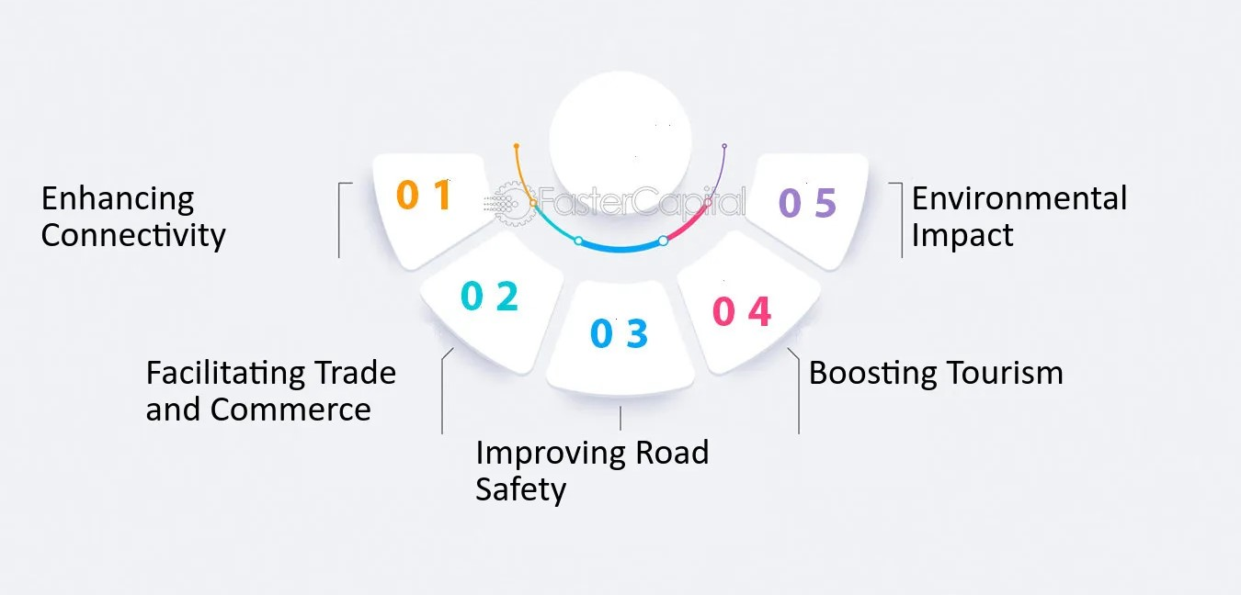

**Figure 2.1:** Understanding the Importance of Road Infrastructure

### 2.2.1 Fundamentals of road infrastructure

1. The efficiency of road infrastructure depends on these essential components cooperating:
2. Road Network: Designed to meet a variety of transportation demands, it consists of highways, streets, and country roads.
3. Road width, surface materials, drainage systems, and signage are all part of the design and engineering process, which guarantees longevity and security.
4. Maintenance & Upkeep: Essential to extending the life of a road, this includes routine resurfacing, repair, and inspection.
5. Additional Features: Interchanges, bridges, and tunnels complete the network by promoting connectedness and allowing for smooth transitions.
6. Tools for Traffic Management: Road markings, speed limit signs, and traffic signals control the flow of traffic, guaranteeing efficiency and safety.

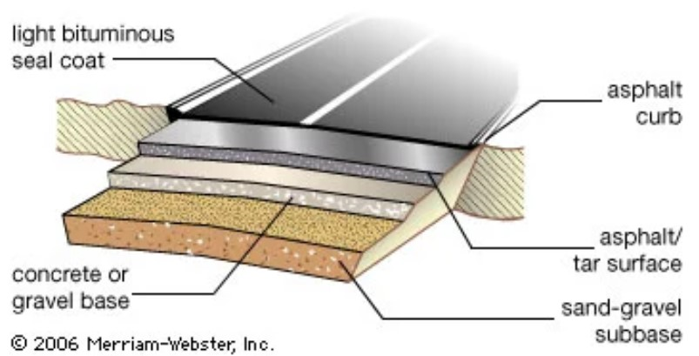

**Figure 2.2:** Elements of a modern asphalt road.

Transportation systems are primarily supported by road infrastructure, which comes in a variety of forms designed for certain functions (Parvard *et al*, 2023). Urban roads connect residential, commercial, and industrial zones within cities and densely populated areas, making them an important means of transportation within these areas. In contrast to its urban counterparts, rural roads serve sparsely inhabited areas by connecting farms, villages, and isolated areas. These roads are frequently essential for rural connectivity and agricultural activity (Ganguli, 2020). The main thoroughfares for transportation, highways link cities and areas, promoting trade and long-distance travel. Each kind is essential to the flow of people, products, and services, which promotes economic activity, improves accessibility, and strengthens the social fabric of communities (Heinonen & Czepkiewicz, 2021)

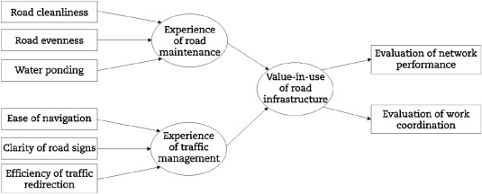

**Figure 2.3**: Road Network Model

### 2.2.2 Roles of Road in Transportation

1. There are several reasons why roads are necessary to support mobility.
2. Connectivity: The primary ways of creating links between rural and urban regions are roads. They facilitate the movement of people, goods, and services, strengthening social and economic linkages across geographical boundaries.
3. Accessibility: They improve access to a wide range of locations, including residences, workplaces, industries, and essential services like hospitals and schools. This accessibility enhances the quality of life for the residents.
4. Trade & Commerce: Roads are necessary to transport goods between production sites, marketplaces, and distribution centers. They facilitate trade by offering a dependable and accessible form of transportation.
5. Mobility: The personalized and adaptable modes of movement made possible by roadways are facilitated by private vehicles, bicycles, and pedestrian walkways.
6. Economic Development: Effective road networks stimulate economic growth by reducing transportation costs, improving market accessibility, and attracting investments due to enhanced connectivity.
7. Support for Agriculture: Rural roads facilitate the transportation of goods from farms to markets, reducing spoilage and providing farmers with access to a greater variety of markets.
8. Travel & Tourism: Roads support the travel and tourism industry and strengthen local economies by providing access to well-liked tourist destinations.
9. Emergency Services: Roads facilitate the rapid access of emergency response vehicles, including fire engines and ambulances, to locations in need of assistance.

## 2.2 Historical Evolution of Road Networks

Throughout history, road networks have changed throughout millennia, reflecting the progress of civilizations and the growth of their cultures. The earliest human settlements created the paths and trails that later became roads, which evolved over time to accommodate growing trade, communication, and social interactions. Early civilizations such as the Roman Empire made significant advancements in road construction by building a vast network of stone-paved roads that facilitated efficient trade and transportation over vast distances. These ancient roadways facilitated cross-cultural interaction in addition to making it simpler for armies and goods to move around, which had an impact on the formation of civilizations (Chu, 2022).

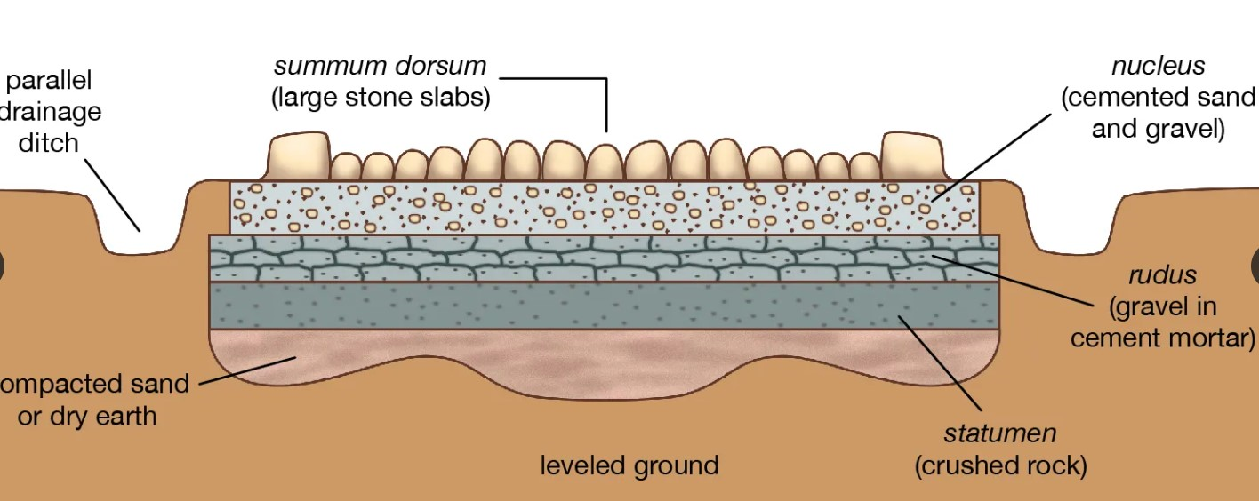

**Figure 2.4**: Ancient Roman road shown in cross section.

Roads in the Middle Ages were neglected due to political unrest and road deterioration brought on by conflict. To pay for upkeep, turnpikes and toll roads were created. Large-scale road construction was prompted by the industrial and Renaissance revolutions. Road networks were transformed by steam-powered transportation in the 19th century, opening the door to contemporary highways and transcontinental routes. This historical period promoted widespread mobility, increased trade, and urbanization, which promoted social progress and economic prosperity (Wang *et al*., 2020).

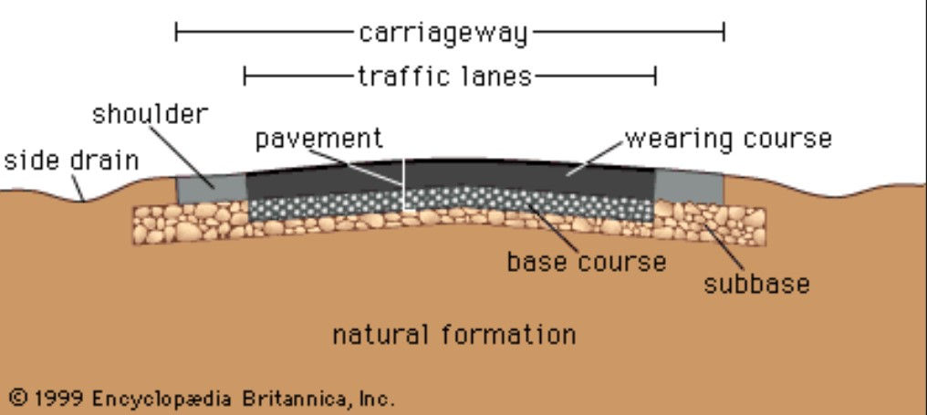

**Figure 2.5:** Schematic Cross Section of a Modern Roadway

It is impossible to overstate how important highways have been to society's growth. Better and larger roads facilitated trade, easier access to markets, and more efficient movement of commodities, all of which contributed to economic expansion. Additionally, road networks promoted intercultural communication and the exchange of innovations, knowledge, and ideas. Roads connected settlements and facilitated the flow of people and goods, which influenced the development of society and encouraged regional integration. (Parvard *et al*, 2023).

**Table 2.1:** Evolution of Road Infrastructure: Historical Milestones

|  |  |
| --- | --- |
| Era | Key Developments in Road Infrastructure |
| Ancient Times | Emergence of footpaths and trails for travel between settlements.  Roman Empire constructs extensive road networks, such as the Appian Way. |
| Middles Ages | Expansion of trade routes, leading to the establishment of trade roads.  Development of cobbled and gravel roads connecting towns and markets. |
| Industrial Era | Introduction of turnpikes, toll roads funded by users for maintenance.  Advancements in road construction with the use of macadam and paving stones. |
| 20th Century | Rise of automobiles leads to the construction of paved roads for cars.  Implementation of highway systems and interstate networks for long-distance travel. |
| Modern Era | Development of expressways, freeways, and high-speed motorways.  Integration of technology for traffic management and navigation systems. |

## 2.3 Road Connectivity in Urban Development

The notion of road connection is a cornerstone of urban development, explaining the role that interconnected road networks play in promoting social progress. It is essential to urban environments, facilitating the smooth flow of people, products, and services that drive economic growth and mold the urban fabric. (Maity *et al*, 2021). The fundamental theories and techniques that direct the strategic planning and construction of road networks are emphasized by urban transportation planning concepts. These guidelines are essential for coordinating the methodical placement of road infrastructure to satisfy the changing needs of urban areas, guaranteeing accessibility, and promoting easy movement within cities. (Ali *et al.*, 2021).

## 2.4 Traffic Flow Analysis and Management

### 2.4.1 Traffic Flow

The study of traffic flow examines how people who utilize transportation—vehicles, pedestrians, cyclists, drivers, and their vehicles—interact with infrastructure, such as highways, signage, and traffic control systems. Understanding and designing the perfect transportation network with few problems with traffic jams and effective traffic flow is the aim.

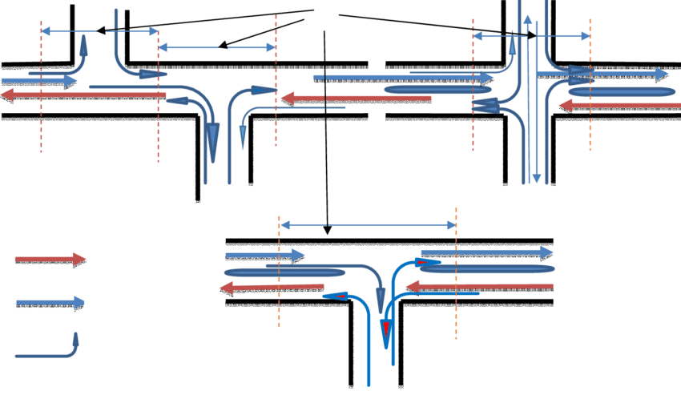

**Figure 2.6:** Schematic diagram of a traffic flow on urban road network

### 2.4.2 Types of Traffic Flow

There are two primary ways that traffic moves. Determining the most appropriate analysis methods and descriptions will be made easier if you have a clear understanding of the type of flow occurring in a given situation.

1. Uninterrupted flow is defined as flow that is controlled by interactions between vehicles and between vehicles and the roadway. For instance, traffic on an interstate highway moves continuously.
2. Flow that has been disrupted by an outside force, like a traffic signal, is known as interrupted flow. Under circumstances of interrupted flow, interactions between vehicles and the roadway and other vehicles play a secondary role in defining traffic flow.

### 2.4.3 Traffic Flow Analysis

Traffic flow analysis is the process of obtaining, examining, and assessing data regarding the movement of vehicles on roadways. Analysts can discover trends, understand the dynamics of congestion, and pinpoint areas that are prone to bottlenecks or inefficient traffic movement by using traffic flow patterns. This study regularly makes use of a wide range of data sources, including sensors, traffic cameras, manual observations, and historical data.

### 2.4.4 Types of Traffic Flow Analysis

Traffic flow analysis categorizes into three primary types, each offering distinct perspectives;

**Table 2.2:** Types of Traffic Flow Analysis: Perspectives and Parameters

|  |  |  |  |
| --- | --- | --- | --- |
| Type | Focus | Parameters | Use |
| Microscopic Traffic Flow | Individual vehicles and interactions | Lane changes, acceleration, overtaking | Understanding detailed driver behaviors |
| Macroscopic Traffic Flow | Collective traffic movement on a larger scale | Average speed, traffic density, flow rate | Assessing congestion, overall traffic conditions |
| Mesoscopic Traffic Flow | Groups of vehicles and their behavior | Interactions within clusters, platooning dynamics | Understanding interactions among clusters of vehicles |

### 2.4.5 Traffic Flow Visualization

Visualizations play a crucial role in understanding traffic flow. The two key methods for visualizing traffic flow are;

1. Speed-Density Diagram
2. Flow-Density Relationship

Experts in transportation and planners benefit from both visuals' ability to convey traffic dynamics. They aid in the development of effective traffic management strategies by helping to identify critical thresholds when traffic conditions change.

### 2.4.6 Speed- Flow- Density Relationship

Density, flow, and speed are all related. The relationships between density and speed are readily apparent in the real world, but the effects of density and speed on flow are less clear.

The following formula links density, flow, and speed in conditions of continuous flow:

q = k * v

Where q = Flow (vehicles per hour)

v = Speed (in miles per hour or kilometers per hour)

k = Vehicle Density (vehicles per mile, vehicles per kilometer)

Since flow is the combination of density and speed, flow equals zero when either or both of these parameters are 0. It is also possible to conclude that the flow is optimal at a specific critical combination of density and speed.

These concepts are demonstrated by two typical traffic scenarios. The first is the modern traffic gridlock, which is characterized by extremely high traffic density and poor speeds. A relatively low flow is produced by this combination. The second scenario is when there is very little traffic and drivers are able to move at a free flow speed without being unduly stressed out by other cars on the road. The ensuing very low flow is the result of the extremely low density making up for the high velocity.

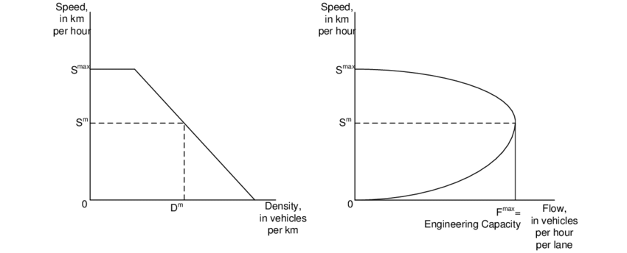

**Figure 2.7**: Speed -Density and Speed-Flow Curves

The relationship between traffic density and speed is illustrated by the Speed-Density Diagram, which shows that average speed usually decreases with increasing traffic density because of congestion and more vehicle interactions. Conversely, the Flow-Density Relationship illustrates the relationship between traffic flow and density, showing that flow frequently increases with density until it reaches its maximum capacity. After this point, higher densities result in lower flow, which is indicative of the beginning of congestion. These visualizations aid analysts and planners in recognizing critical thresholds where traffic conditions shift, guiding the formulation of targeted traffic management strategies to optimize road efficiency and alleviate congestion.

### 2.4.7 Traffic Flow Parameters

1. Speed (v): Distance traveled per unit of time by a vehicle. Average speed is the space mean speed calculated by averaging individual vehicle speeds.
2. Volume: Number of vehicles passing a point on a roadway in a specified time period.
3. Traffic Flow (q): Rate at which vehicles pass a given point on the roadway, usually measured in vehicles per hour.

q = ρ * v

where q = Traffic flow rate

ρ = density and v = speed

1. Peak Hour Factor (PHF): Ratio of the hourly flow rate to the peak 15-minute rate of flow expressed as an hourly flow.
2. Density (k): Number of vehicles on a given length of roadway, reported in vehicles per mile or kilometer.
3. Headway (h): Temporal space between two vehicles, measured in seconds from the arrival of the leading vehicle to the following vehicle.
4. Spacing (s): Physical distance between the front bumpers of leading and following vehicles, reported in feet or meters.
5. Gap (g): Time between the departure of the first vehicle and the arrival of the second at a designated point, measured in seconds.
6. Clearance (c): Distance between the rear bumper of the leading vehicle and the front bumper of the following vehicle, reported in feet or meters. It is the spacing minus the length of the leading vehicle.

Traffic flow analysis is a crucial tool for understanding the intricate dynamics of urban mobility. It encompasses an array of methodologies used to assess traffic patterns, congestion hotspots, and their notable impacts on transportation network planning and development. Traffic flow analysis elucidates vehicle movement fluctuations and identifies sites susceptible to traffic bottlenecks through the application of techniques such as density evaluations, speed analyses, and traffic volume counts. Urban planners can strategically deploy resources and infrastructure to lower traffic demands thanks to this empirical knowledge. It also serves as a guide for creating an effective road network. (Kolesov *et al*., 2022)

Traffic management techniques are therefore necessary to reduce traffic and enhance the overall efficacy of road networks. These strategies include, among many other things, traffic signal optimization, intelligent transportation systems, and lane management. Adaptive traffic signals, real-time traffic monitoring, and congestion pricing schemes are some of the tools that urban authorities can use to optimize traffic flow and minimize congestion. Additionally, innovative solutions like bike lanes, pedestrian-friendly infrastructure, and dedicated bus lanes promote a more sustainable and balanced urban mobility scenario. (Kim *et al*., 2023)

In a paper published in 2020, Zheng and Huang addressed urban congestion by accurately predicting traffic flow using deep learning—more particularly, LSTM networks. By utilizing actual traffic data, the LSTM model outperformed conventional approaches in forecasting accuracy, exposing dynamic traffic patterns and assisting in the making of wise traffic management decisions. All things considered, the research demonstrates how deep learning may improve traffic flow analysis and management when it comes to alleviating urban congestion. .

## 2.5 Infrastructure Development and Management

Examining different models is crucial for effective planning, construction, and maintenance of road networks in the field of infrastructure development. A range of approaches, from traditional to innovative, influence road design and management and have an impact on the long-term sustainability and viability of the roadways. Moreover, road infrastructure in Nigeria is significantly impacted by the variety of urban-rural dynamics. Depending on the distinct urban and rural characteristics of the area, developing and maintaining the road network presents a number of obstacles. Customized solutions are therefore required to solve issues with connectivity, uneven resource distribution, and the disparities in infrastructure requirements between urban and rural locations. (Chang *et al*., 2023).

The viewpoint on road infrastructure in Nigeria draws attention to important facets of growth and administration. Numerous issues plague the nation, such as poor upkeep, financial limitations, and a variety of topographical features that affect the quality of roads in both urban and rural areas. In order to sustain economic activity, urban areas frequently need strong and connected road networks, whereas rural areas need infrastructure upgrades to close accessibility gaps. In order to promote national economic growth and social cohesion, Nigeria's infrastructure planning must balance these urban-rural dynamics, highlighting the need for customized methods that take local contexts, resource allocation, and fair infrastructure development into account. (Ali *et al*., 2020).

## 2.6 Environmental Sustainability in Road Infrastructure

Henke *et al* (2020) carried out a study on decision-making in the transportation industry, with a particular focus on a sustainable evaluation technique for road infrastructure. They addressed the serious issue of the detrimental externalities that regular transportation activities create, which have an effect on the environment and people's quality of life. The goal of the study was to provide a sustainable evaluation technique for determining how new transportation infrastructure would affect the environment. They evaluated the social, economic, and environmental sustainability of a "greenway" refurbishment project in southern Italy by a quantitative approach.

In the investigation of the impact of road infrastructure on economic sustainability, Ben (2021) emphasized the critical role that road infrastructure plays in ending hunger, lowering poverty, and improving the quality of human existence. The study emphasized the importance of road transportation as a door-to-door mode of delivery for getting finished items to customers. It also highlighted how road development may unlock the potential of rural communities by turning subsistence farming into a successful commercial system. In order to understand how road infrastructure contributes to economic growth, the article addressed a number of economic theories, including neoclassical growth theory, endogenous growth theory, growth pole, and growth center theory. In order to disperse demand, lessen traffic, increase reliability, and boost the country's economy as a whole, it suggested that Nigeria use road pricing schemes. The report's conclusion advocated for public investment centered on economic returns.

Ruiz & Guevara (2020) used a system dynamics technique to study the economic and environmental effects of road infrastructure. Their research highlighted the significance of giving sustainable practices in maintenance precedence over green methods in new construction by contrasting traditional and sustainable procedures in road construction and maintenance. Their research highlighted the significant effect of maintenance on costs and emissions, recommending a focus on road maintenance to enhance road network conditions. It proposed their model as a tool for policy development and suggested further research on green interventions in existing road networks globally.

## 2.7 Environmental impact assessment

The study by Mavrin *et al*. (2020) focuses on improving traffic management efficiency through infrastructure modernization in order to mitigate the environmental impact of road transportation. The street and road network of a medium-sized city was examined for trouble regions, and simulation models were created using a discrete-event methodology. Through computer tests and proposed steps for modernization, the study demonstrated significant potential for enhancing traffic flow characteristics and so mitigating environmental effect. This study highlights evidence-based strategies for efficient traffic management and offers doable recommendations for improving urbanized regions' infrastructure.

The goal of the study by Onokala & Olajide (2020) was to draw attention to the difficulties Nigeria's main transportation modes confront in advancing the nation's economic development in the twenty-first century. They went into great detail about how each mode—roads, rivers, trains, and airplanes—was developed historically and how each had previously contributed to economic advancement. The report explores the current issues, focusing mostly on the overuse and improper management of road transportation, the underutilization of rivers' capacity, the antiquated railway systems, and the necessity of substantial improvements in air transportation. These difficulties lead to environmental problems, a high frequency of traffic accidents, inefficient ports, and lost import possibilities in Nigerian seaports. In order to overcome these obstacles and make it possible for different modes of transportation to more effectively contribute to Nigeria's

## 2.8 Sustainable road network models

In Nabeeh's (2023) study, an Intelligent Neutrosophic Multi-Criteria Decision-Making (MCDM) model was used to evaluate sustainable growth in various road transport systems. The study looked at both economic and environmental aspects, highlighting the need to lower carbon emissions, improve energy efficiency, and take into account larger societal goals. In order to reconcile conflicting aspects such as energy efficiency, legislative frameworks, economic influence, and environmental impact, the MCDM model was utilized. The research attempted to completely analyze the sustainability of contemporary road transport systems by including a DEMATEL approach and 14 secondary criteria. This would help stakeholders plan for sustainable transportation in the future.

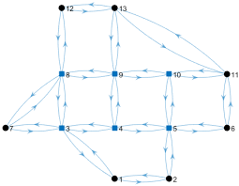

**Figure 2.8:** Dynamic Road Network Model

Ruiz and Guevara (2020) focused on road preservation strategies in Colombia while delving deeply into sustainable decision-making for road construction. System dynamics (SD) and the analytical hierarchical process (AHP) were used in their hybrid methodology to evaluate several methods to sustainable road maintenance. They used the SD model to analyze road conditions, costs, and emissions in order to evaluate various maintenance policy choices for Colombia's national road network through a case study. The results showed that short-term maintenance methods were frequently influenced by economic factors, which prioritized remedial maintenance over predictive maintenance. Nonetheless, the analysis showed that predictive maintenance made a substantial contribution to both lowering CO2 emissions and keeping roads in good condition.

The authors of the study (Ogryzek *et al*., 2020) provided guidelines and tactics for creating a city's transportation network to be more effective. They examined Vilnius' sustainable transportation policies and mobility, drawing inspiration from cities such as Copenhagen and London. The study investigated a number of factors that affect sustainable transportation, including bicycle and pedestrian trips, automobile usage, public transportation indicators, and car usage itself. It suggested fixes included the creation of bike routes, shared spaces, and changes to policies. Graph theory techniques and geographic information system (GIS) technologies were used to evaluate each of these.

# CHAPTER THREE

# MATERIALS AND METHODS

## 3.1 Brief Description of the study area

Ogbomosho North is a Local Government Area in Oyo State. Currently led by Kabir Akanji, the chairman, the organization's headquarters are located in Kinnira. Ladoke Akintola University of Technology (LAUTECH), one of Nigeria's premier educational institutions, and its teaching hospital are housed by the local government

The Nigerian Baptist Medical Center and the Bowen University Teaching hospital are both situated there. Islam and Christianity are the two most prevalent religions among the many Yoruba people who live in the Local Government Area. The Ogbomoso North Local Government Area is home to two noteworthy landmarks: the Bowen University Teaching Hospital and the Ladoke Akintola University of Technology.

Ogbomoso North Local Government Area was established on September 27, 1991, following its creation from the original Ogbomoso Local Government Area on April 1, 1973. Ogbomoso North Local Government Area has an average temperature of 28 degrees Celsius and a land area of about 207 square kilometers. The area experiences 9 km/h average wind speeds and 1830 mm of yearly precipitation.

Ogbomoso North Local Government Area has a large number of banks, hotels, restaurants, factories, and schools that are run by both public and private entities. The Local Government Area boasts a thriving trade economy with various marketplaces, including Wazo and Ojajagun markets, where a wide variety of commodities are transacted. (Adewuyi *et al,* 2020)

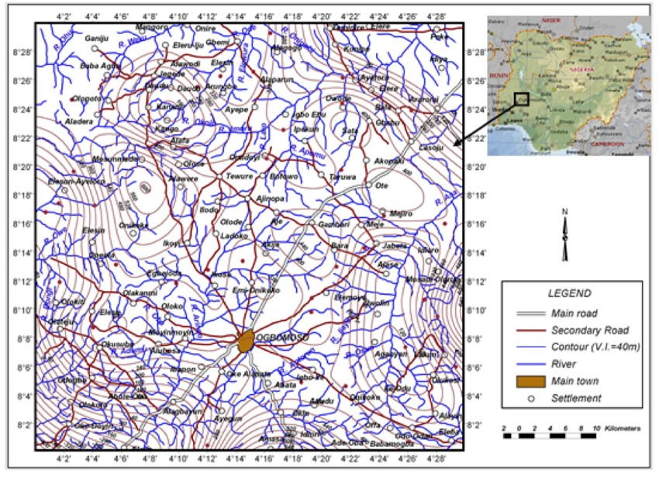

**Figure 3.1**: Map of Ogbomoso North (inset map of Nigeria)

### 3.2 Research design

A thorough mixed-method approach is used in the research design to investigate road connectivity in Ogbomoso North, effectively combining quantitative and qualitative approaches. In order to guarantee a comprehensive grasp of the nuances surrounding the road network, traffic patterns, and connection issues common in the research area, this hybrid design has been purposefully adopted. Through the use of this dual methodology, the research seeks to capture the contextual and sensory components as well as the statistical aspects of traffic flow and road infrastructure as experienced by the local population.

The investigation's study topics explore the state of the road infrastructure as it is, the locations of congestion hotspots, the kinds and capacities of the current roadways, and tactical ways to improve traffic flow and reduce congestion in Ogbomoso North.

To guide the investigation, the following research questions have been formulated:

1. What is the state of Ogbomoso North's road system right now, and how does it affect connectivity overall?
2. In the research region, where are the main points of congestion and disturbances in traffic flow?
3. What kinds of roads are there now—highways, city roads, country routes—and how might their capacities be maximized to provide better connectivity?
4. What tactical options are available to improve Ogbomoso North traffic flow and lessen congestion?

### 3.3 Data Collection

The study model was developed by means of a thorough investigation of the road network's spatial organization, clarifying the various purposes and roles of various places in supporting the overall connectivity and developmental dynamics in Ogbomoso North. The information comes from Oyo State's Ministry of Lands, Housing, and Physical Planning in Ibadan, and it is essential to comprehending the region's connectivity and infrastructure.

**Table 3.1**: Table of Locations and Places in Ogbomosho North (considered in the study)

|  |  |  |  |
| --- | --- | --- | --- |
| **Location/Place Type** | **Name** | **Description** | **Significance** |
| Major Towns | Ogbomoso | LGA headquarters, Lautech, Ogbomoso Grammar School, Baptist Hospital, central markets | Key economic and educational hub |
|  | Ilorin-Ibadan Expressway | Major corridor connecting Ogbomoso to other cities | Vital for regional trade and transportation |
|  | Saki | Town known for pottery and historical sites | Tourist destination and agricultural center |
|  | Ayegun | Growing residential area with agricultural significance | Community development and resource access |
|  | Iyana Offa | Junction connecting Ogbomoso to Offa and Kwara State | Access to neighboring region and trade routes |
| Important Landmarks | Ladoke Akintola University of Technology (LAUTECH) | Prominent university attracting students and professionals | Educational and intellectual hub |
|  | Ogbomoso General Hospital | Main medical facility for the LGA | Healthcare access and essential services |
|  | Ogbomoso Central Market | Bustling marketplace for various goods and local produce | Economic activity and cultural showcase |
|  | Soun Ogunlola Palace | Official residence of the Soun of Ogbomoso | Traditional leadership and cultural symbol |
|  | Baptist Seminary | Theological institution training religious leaders | Spiritual development and community influence |
| Road Network Segments | Ilorin-Ibadan Expressway | Major north-south corridor | Regional connectivity and traffic flow |
|  | Ogbomoso-Saki Road | Connects Ogbomoso to Saki and beyond | Access to agricultural and rural areas |
|  | Ogbomoso-Iwo Road | Links Ogbomoso to Iwo in Osun State | Inter-state connectivity and trade opportunities |
|  | Ogbomoso-Offa Road | Provides access to Offa and Kwara State | Regional exchange and cultural interaction |
|  | Inner-city roads | Connect various neighborhoods and landmarks within Ogbomoso town | Local accessibility and community mobility |

### 3.4 Data Profiling

The statistics that have been gathered include of the network and road infrastructure of Ogbomoso North, which includes major highways, expressways, and smaller roads.

### 3.4.1 Traffic Flow Dataset

An essential part of the extensive research on road connectivity in Ogbomoso North is the Traffic Flow dataset. The primary purpose of this dataset is to record the dynamics of vehicle movement in the research region across various road segments and intersections. Important traits and attributes consist of:

1. Traffic volumes are expressed as the number of cars that pass a particular location in a predetermined amount of time (vehicles/hour).
2. Congestion Points: Shows places where traffic is heavier than usual and may be a source of congestion.
3. Flow Patterns: Shows the temporal trends in traffic, giving information about peak times and daily variations.

Units: Traffic volumes is typically measured in vehicles per hour.

### 3.4.2 Road Condition and Maintenance dataset

The condition of Ogbomoso North's road infrastructure is assessed using the Road Condition dataset. It evaluates the physical characteristics of major, minor, and highways roads. Important traits and attributes consist of:

1. Road Types: This section divides roads into major, minor, and highway categories.
2. Condition assessment: Offers information about the state of roads today, emphasizing areas that might need repair or upkeep.
3. Analyzes each road segment's capacity to see how well it can accommodate vehicle traffic.
4. Units: Capacity is commonly expressed in cars per hour, and condition ratings might be qualitative (excellent, fair, or poor).

### 3.4.3 Road Network Model Dataset

The Road Network Model dataset provides a geographical depiction of Ogbomoso North's whole road network. Locations, sections of roads, and patterns of connectedness are all included. Important attributes and features of this dataset consist of:

1. Coordinates and geographical data are provided for every site and road segment in the geographic information.
2. Connectivity analysis: locates important network connectors as well as important road corridors and crossroads.
3. Towns and Sites: Identifies important towns, intersections, and landmarks along the road network.
4. Units: Latitude and longitude are used to measure coordinates. .

### 3.4.5 Socioeconomic Impact Dataset

The Socioeconomic Impact dataset explores the wider effects that road connection has on the Ogbomoso North community. It looks at social, cultural, and economic facets. Important traits and attributes consist of:

1. Economic Hubs: Describes locations that are essential to economic activity, like markets, schools, and hospitals.
2. Emphasizes locations and places having historical or cultural significance.
3. Impact of Traffic on Businesses: Analyzes the effects of traffic flow, or congestion, on nearby companies.

Units: Quantitative and qualitative impact assessments are both available.

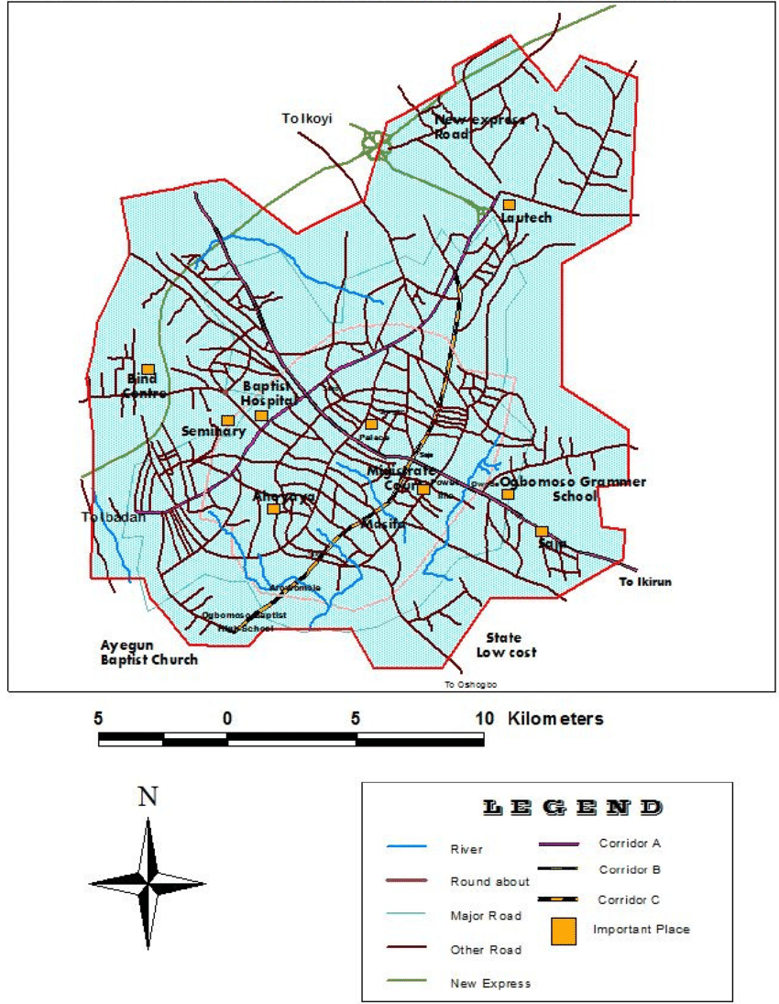

**Figure 3.2:** Map of Ogbomoso township showing the road network.

## 3.5 Data Analysis Techniques

The investigation of the gathered datasets relating to the road connectivity in Ogbomoso North constitutes the data analysis component of this study. Statistical tools and exploratory data analysis techniques, including univariate, bivariate, and multivariate analysis, are utilized to help the analytical process. Microsoft Excel, Stata, and the Statistical Package for Social Science (SPSS) are among the primary software tools used. .

### 3.5.1 Traffic Flow Patterns Analysis

In the descriptive statistics phase, traffic flow patterns are thoroughly examined using SPSS and Excel. Calculating descriptive statistics can provide valuable insights into the central tendency and variability of traffic patterns in the studied area. Examples of these statistics are mean traffic flow, standard deviation, and percentile values.

### 3.5.2 Road Condition Assessment

The univariate approach uses frequency distributions to focus on certain factors, specifically road conditions, while utilizing exploratory data analysis. Bivariate analysis explores the connections between traffic flow and road conditions, offering a detailed comprehension of their interaction.

### 3.5.3 Spatial Layout Exploration

In this step, the spatial distribution of road networks was thoroughly evaluated. Here, essential areas that greatly enhance Ogbomoso North's overall connection and developmental characteristics were identified using GIS tools.

3.5.4 Hotspot Identification for Congestion:

The application of spatial analysis techniques and clustering algorithms was made here since the goal is to identify areas of congestion by closely examining the spatial distribution of traffic flow. To identify particular regions with high traffic density, clustering methods are used, which helps to provide a more focused understanding of congestion sites.

### 3.5.5 Multivariate Analysis for Overall Connectivity

The study evaluated the combined effects of several variables, such as traffic volume and road conditions, on the total road connectedness within the study area using regression analysis in SPSS.

# REFERENCES

Ali, L., Khan, S., Shah, S. J., Ullah, A., Ashraf, H., Ahmad, M., Begum, A., Han, H., Ariza-Montes, A., Araya-Castillo, L., Khan, A. U., Anas, M., & Khan, A. M. (2021, December 6). *Road and Transportation Lead to Better Health and Sustainable Destination Development in Host Community: A Case of China Pakistan Economic Corridor (CPEC)*.

Munir, T., Dia, H., & Ghaderi, H. (2021, October 31). *A Systematic Review of the Role of Road Network Pricing in Shaping Sustainable Cities: Lessons Learned and Opportunities for a Post-Pandemic World*.

Akinola, S. F. (2023). *Using GIS Network Modeling to Evaluate Access Disruption to Critical Health Facilities During Flood Events*. Scholar Works @ *Georgia State University.*

Khuvung, Z., & Odyuo, M. N. (2023, May 23). Study on the Impact of the Nationwide Rural Road Connectivity Programme in India (PMGSY) on the Socio-Economic Status of the Rural People under Wozhuro Rural Development Block, Wokha District, Nagaland, India. *Asian Journal of Agricultural Extension, Economics & Sociology*, *41*(7), 199–208.

Oluwaseyi, A. D. (2021, April 6). *Indoor Environmental Quality of Households Resident Districts Within Ogbomoso Township, Nigeria | LC International Journal of STEM (ISSN: 2708-7123)*. Indoor Environmental Quality of Households Resident Districts Within Ogbomoso Township, Nigeria | LC International Journal of STEM (ISSN: 2708-7123).

Pavard, A., Dony, A., & Bordin, P. (2023). *Road Modelling for Infrastructure Management – The Efficient Use of Geographic Information Systems.* Paper Under-review since 2023.03.13.

Ganguli, B. (2020, November 12). *Rural Road Connectivity: The Artery of the Economy*. Rural Road Connectivity: The Artery of the Economy by Barna Ganguli: SSRN.

Heinonen, J., & Czepkiewicz, M. (2021, June 9). *Cities, Long-Distance Travel, and Climate Impacts.* *Urban Planning*, *6*(2), 228–231.

Chu, B. B. (2022, October 25). The historical significance of the silk road. *Значение Цифровых Технологий В Изучении Истории Узбекистана*, *1*(01), 410–412.

Wang, Yu, Kwan, Zheng, Miao, & Li. (2020, November 21). *The impacts of road network density on motor vehicle travel: An empirical study of Chinese cities based on network theory* - ScienceDirect.

Maity, B., Mallick, S. K., & Rudra, S. (2021). *Integration of urban expansion with hybrid road transport network development within Haldia Municipality, West Bengal*. The Egyptian Journal of Remote Sensing and Space Science, 24(3, Part 1), 471-4832.

Kolesov, V. I., Sorokin, D. A., & Gulyaev, M. L. (2022). *Urban Mobility Management By Means Of Traffic Flow Dynamics*. *Транспорт Наука Техника Управление*, *8*, 3–10.

Kim, J., Jang, H., Han, E., & Ko, E. (2023, October 31). Analysis of Traffic Flow Based on Autonomous Vehicles’ Perception of Traffic Safety Signs in Urban Roads. *The Journal of the Korea Institute of Intelligent Transport Systems*, *22*(5), 148–162.

J. Zheng and M. Huang, "*Traffic Flow Forecast Through Time Series Analysis Based on Deep Learning*," in IEEE Access, vol. 8, pp. 82562-82570, 2020.

Ali, R., Barra, A. F., Berg, C. N., Damania, R., Nash, J., & Russ, J. (2020, May 1). *Transport Infrastructure and Welfare: An Application to Nigeria*. Transport Infrastructure and Welfare: An Application to Nigeria.

Henke, I., Cartenì, A., Molitierno, C., & Errico, A. (2020, January 21). *Decision-Making in the Transport Sector: A Sustainable Evaluation Method for Road Infrastructure*. MDPI.

Ben, S. O. (2021, October 5). *Significance of Road Infrastructure on Economic Sustainability | American International Journal of Multidisciplinary Scientific Research*. Significance of Road Infrastructure on Economic Sustainability | American International Journal of Multidisciplinary Scientific Research.

Ruiz, A., & Guevara, J. (2020, May). Environmental and Economic Impacts of Road Infrastructure Development: Dynamic Considerations and Policies. *Journal of Management in Engineering*, *36*(3).

Mavrin, V., Magdin, K., Shepelev, V., & Danilov, I. (2020). Reduction of environmental impact from road transport using analysis and simulation methods. *Transportation Research Procedia*, *50*, 451–457.

Ogryzek, M., Adamska-Kmieć, D., & Klimach, A. (2020). *Sustainable Transport: An Efficient Transportation Network—Case Study. Sustainability*, 12(19), 8274.

Adewuyi, G. K., Adeyemo, A. K., & Adejumo S. A (2020). *Use of geographic information of Oyo State, Southwestern Nigeria*. *International Research Journal, 6*(12),